“Tragic January:” Under a state of emergency in Almaty, Kazakhstan

Kristopher White
College of Social Sciences
KIMEP University
Almaty, Kazakhstan
kwhite@kimep.kz

Introduction

In early January 2022, protests, demonstrations, and subsequent violence vaulted the republic of Kazakhstan to the rare positional forefront of global news coverage. There, pundits and regional experts based outside of Kazakhstan discussed internal power struggles between political elites (current President Kassym-Jomart Tokayev and his predecessor, first president and longtime ruler Nursultan Nazarbayev), Vladimir Putin and the geopolitical influence of Russia in former Soviet space, previous so-called ‘Color’ revolutions, and the first ever deployment of Russian-led Collective Security Treaty Organization (CSTO) troops within a member state. Meanwhile, the overwhelming majority of local residents of Almaty, Kazakhstan’s largest and most cosmopolitan city, remained locked within their homes for days and days with no internet access, and an effective information blackout interrupted by the occasional domestic SMS message or mobile phone call. Communicating with anyone outside of Kazakhstan was impossible. Precautionary rationing of food and water added significant anxiety and uncertainty, not knowing when, or even if, order would be restored.
The origin appears to have been peaceful protests in Zhanaozen, Kazakhstan, against the government’s decision to remove a subsidy for liquefied petroleum gas (LPG), effectively doubling the cost of this popular fuel overnight. Soon protests diffused spatially across Kazakhstan, in time revealing discontent with a whole host of social ills. In Almaty, unknown groups appeared to hijack the protests. Once violence escalated, government troops responded with force. The events resulted in more than 200 deaths and tens of thousands of arrests. For a more detailed timeline of events, see e.g. Al Jazeera English, 2022.
This photo essay presents images, all made by the author between January 11 and 15, 2022, documenting the aftermath of violence during a state of emergency in central Almaty, Kazakhstan. Accompanying text is augmented by the author’s own personal experiences and observations, as well as interview responses from Kazakhstani citizens and Almaty residents. At the time of writing much remains uncertain. Who exactly hijacked the peaceful demonstrations seems to be the major uncertainty, with the government claiming international terrorists, others suggesting actors loyal to former president Nursultan Nazarbayev. Even the nomenclature assigned to these events is unclear. Local outlets and the government appear to be using the term ‘Tragic January’ (Kazakhstan Embassy, 2022).

-

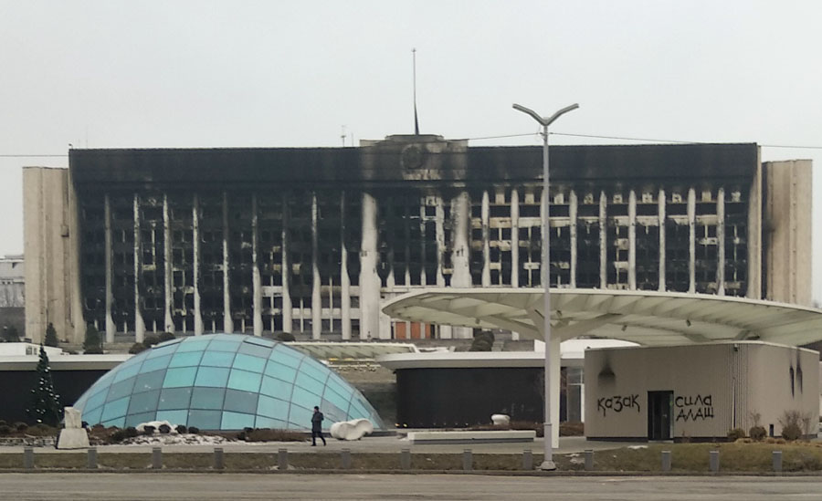

Figure 1: Burned Akimat (Mayor’s office, city govt.) building of Almaty, Kazakhstan

This large city government building faces north across Satpaev Street and overlooks Independence Square, what most refer to as New Square (as opposed to the Old, Soviet-era square elsewhere in the city). The prominent feature in this square is the obelisk monument (behind the photographer and unseen here, though shown best in Figure 20 below) to Kazakhstan’s independence, December 16, 1991. Adding to this image’s shock value is the charred Kazakhstani state flag and state emblem at the building’s center top. This part of the city became, by the night of January 4, the epicenter of violence and the focus of global television broadcasts. Occasional gunfire could still be heard in this part of the city into January 6 and 7. Marat¹, a pension-aged man living close to New Square, described a harrowing experience. Thinking the explosions and gunfire were fireworks for someone’s wedding, “I opened my window to try and see what was going on. I soon knew it wasn’t fireworks. I saw crowds and crowds of people. Then tear gas rushed into my apartment and I felt stinging pain in my eyes. I tried over and over to wash my face and eyes, but could not stop crying.”

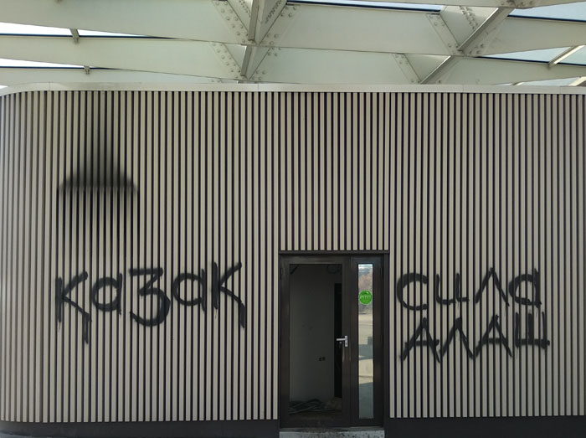

Figure 2: Black spray paint, Kazakh, Alash power

In black spray paint, and in Kazakh language, this image is another prominent visual element of the previous scene above. “Kazakh” to the left and “Alash Power” to the right. According to legend, Alash was the common ancestor from whom the three Kazakh zhuz (tribes) descended. In the early twentieth century Kazakh intelligentsia formed a democratic Alash Orda political party championing unity, national identity, and independence for Kazakhs. Today, Alash has come to represent a certain ethnic cohesion and strength. This expression of Kazakh nationalism (as opposed to Kazakhstani) appears to indicate the primacy of ethnicity ahead of the State. Such sentiment may come at the expense of the more than 100 other ethnicities calling Kazakhstan home.

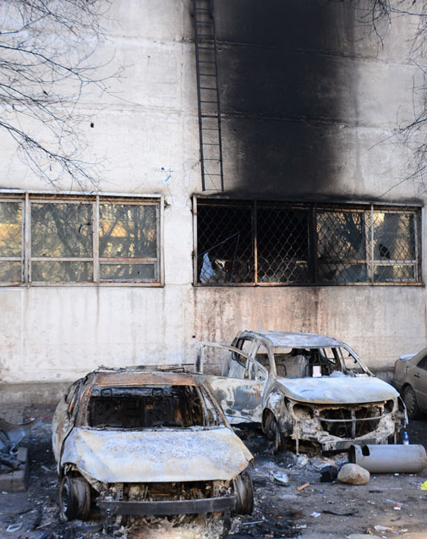

Figure 3: Burned automobiles

Behind a telecommunications building that abuts Independence Square, this parking area featured a number of burned out cars and evidence of façade-scarring flames. The automobile to the right features a hand-written note in Russian language, “Request – Please do not remove my car from this accident scene. Call me.” Followed by the owner’s name and mobile phone number. This note offers a humanizing reminder of the violence and damage that impacted human beings, ‘ordinary’ people who are living and working in Almaty, peacefully, to provide for themselves and their families.

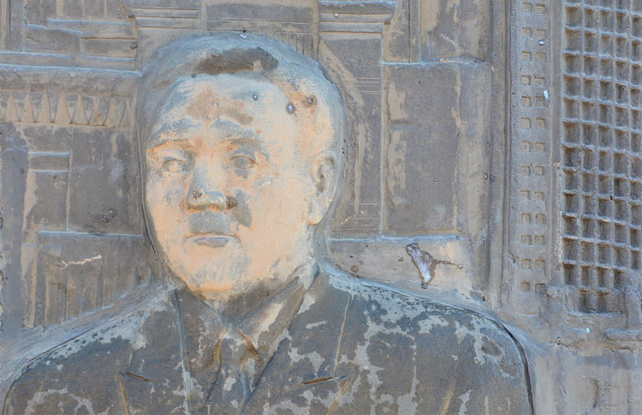

Figure 4: Rendition of Nursultan Nazarbayev, first President of Kazakhstan

Kazakhstan’s first president, Nursultan Nazarbayev, is featured here on a bas-relief panel, a group of which partially ring Almaty’s monument to Kazakhstan’s independence. The muddied and damaged surface also appears to show frozen human saliva just above the former president’s left shoulder. Nazarbayev held Kazakhstan’s top administrative post from 1989, when he was appointed by Soviet premier Mikhail Gorbachev, until 2019 when he voluntarily stepped down and selected Kossym-Jomart Tokayev to succeed him. At the time of writing, Nazarbayev still holds the honorary lifetime title of El basy (Kazakh language for Leader of the Nation), though he has been replaced, (by Tokayev) as Chair of the powerful Security Council, and numerous Nazarbayev family members and loyalists have been removed from their administrative posts.

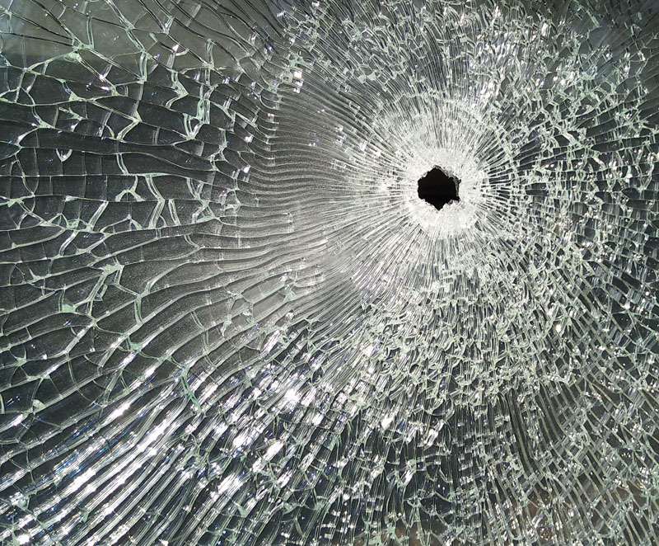

Figure 5: Bullet hole in window

Visual evidence of gunfire is pervasive across the entire Independence Square area. While initial marching and protests were peaceful in Almaty, by the evening of the 4th violence erupted here. Clashes with police, recorded by television cameras, and flash grenades and bullets made the scene sound like a war zone.

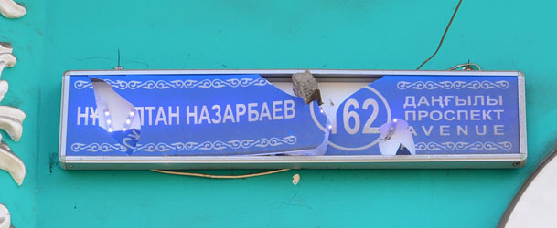

Figure 6: Sign of the avenue named after Nursultan Nazarbayev

A damaged Nursultan Nazarbayev avenue sign features the street name in Kazakh language followed by “avenue” in (from top) Kazakh, Russian, and English languages. The author explored many individual streets within this area and found no damage whatsoever to other streets’ signs. While this particular sign remains legible, along this street closer to the Independence Square epicenter, many of these signs were completely destroyed.

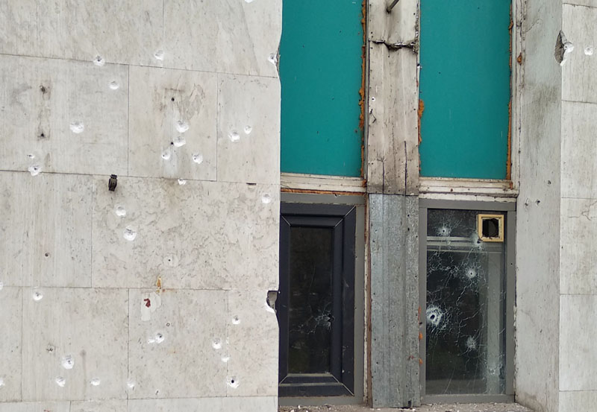

Figure 7: Bullet holes

In addition to deaths, hospitalizations, and arrests, significant property damage also occurred throughout Almaty. Early estimates placed the total damage associated with these January events at between $2 and $3 billion (Karibayeva, 2022).

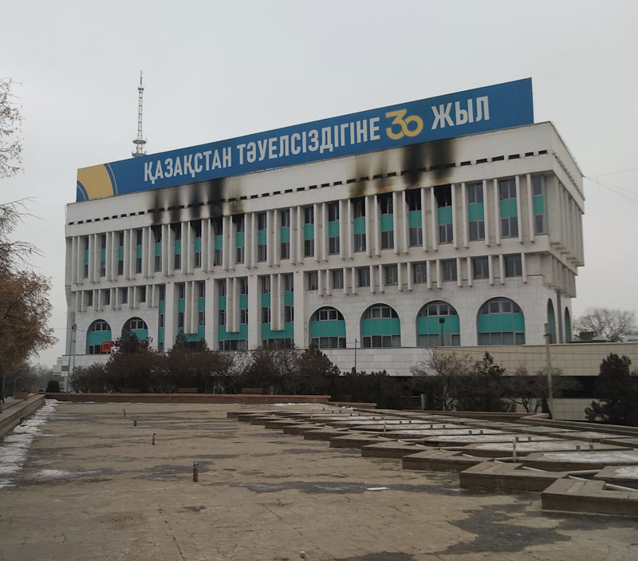

Figure 8: Fire damage, New Square

On the western edge of Independence Square, fire damage leaves fingerprint-like scars on this building’s white façade. Across the top a message in the Kazakh language trumpets Kazakhstan’s 30 years of independence, a holiday celebrated on December 16. A sister building to the East features the same message and design in the Russian language.

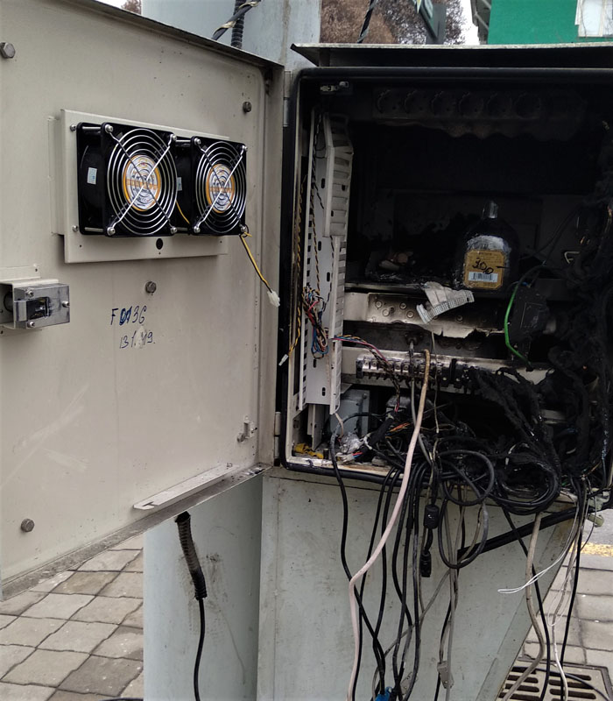

Figure 9: Burned electrical box

This photo, taken January 11, shows a charred electrical junction box on the corner of Nursultan Nazarbayev and Abai Avenues. On one walk past this site, it was being guarded by two SCTO troops. While the internet was shut down by the government during the height of the events, there is a sense of relief that power was never interrupted.

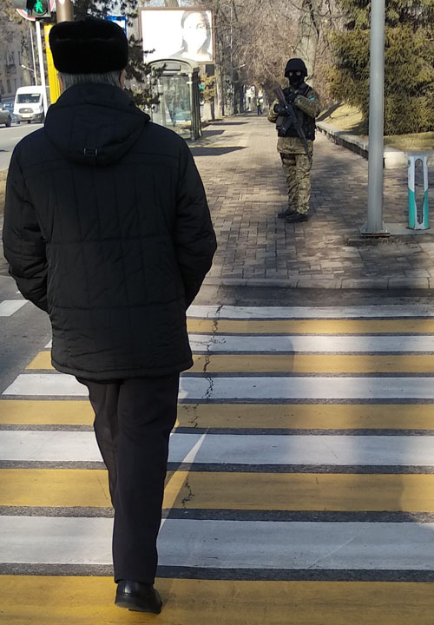

Figure 10: Pedestrian in crosswalk and soldier

The appearance of CSTO troops in camouflage and carrying automatic weapons on January 11 was, perhaps counter-intuitively, a welcome sight. President Tokayev’s quick request for military support from the Collective Security Treaty Organization (CSTO) to suppress the unrest was granted. Indeed this became the first ever deployment of CSTO troops (most of those sent here were Russian soldiers) within a member state. Formed in 1992, this regional security grouping currently includes Russia, Kazakhstan, Kyrgyzstan, Tajikistan, Armenia, and Belarus. While official chairmanship rotates among member states, the CSTO is a Russia-dominated security grouping (see Cooley, 2022). One of the most puzzling aspects of these highly uncertain days was the odd lack of police presence throughout much of Almaty in the days directly following the peak of violence. Criminals and looters took advantage of the police absence across the city, adding to property damage and overall feelings of insecurity among law-abiding residents. Halima, a long-time Almaty resident, summed up her own personal insecurity, saying, “Many of us here in my apartment building are elderly and live alone. I was very afraid of damage to our apartments, especially as there were no police around at all.” Another citizen, Gulya, described a store being vandalized and looted in the early morning darkness. “I was looking down on the storefront and I noticed men walking back and forth. One broke the front window. Another entered the store, later emerging with boxes. This repeated for more than an hour, the entire time no police arrived whatsoever.”

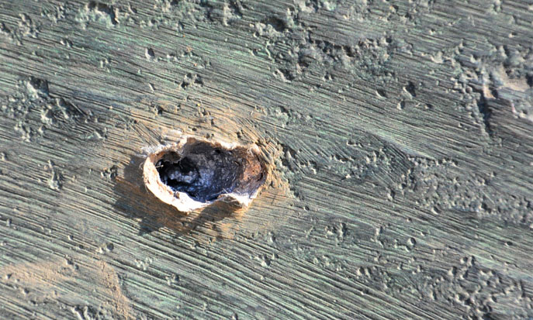

Figure 11: Lodged bullet

A lead-filled bullet crater offers yet another visual reminder of violence and the loss of human life. At the time of writing, much uncertainty remains with respect to who is responsible for the violence, and to what end. Were people angrily and violently protesting against the continued power and wealth held by Nazarbayev and his family? Was this a coup d'état against the current Tokayev regime? Was this an instance of domestic or international terrorism? President Tokayev’s public statements seem to indicate the latter. For Almaty residents, the following message aired near the start of curfew on television and was broadcast in both Russian and Kazakh languages on outdoor loudspeakers, echoing through the night. “Dear Almaty residents! In Almaty an anti-terrorist operation is going on to destroy gangs. The main purpose is to stop terrorists and ensure security. In case anti-terrorist actions take place near your home, we recommend to not get close to windows, and do not go outside. Hide in a safe place and keep watch over children and elderly.”

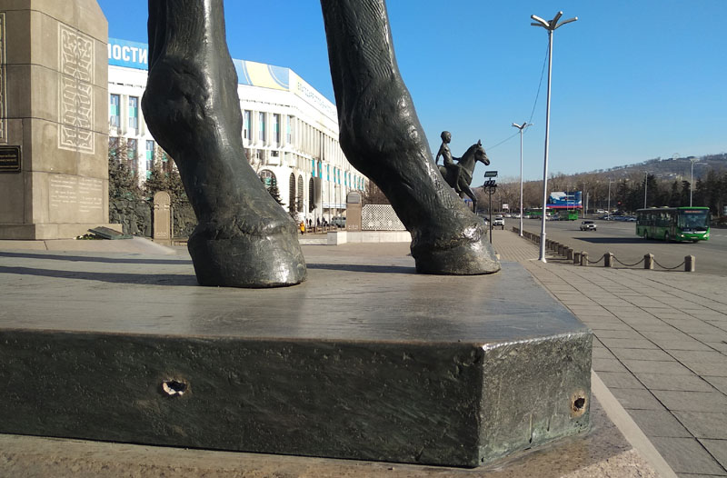

Figure 12: Independence square bullet holes

A wider-angle view from the same location as the previous image looks east along Satpaev Street. By January 14, the date this image was made, a semblance of normalcy had returned, including the operation of public transport (buses in this case) and a slight increase in automobile traffic.

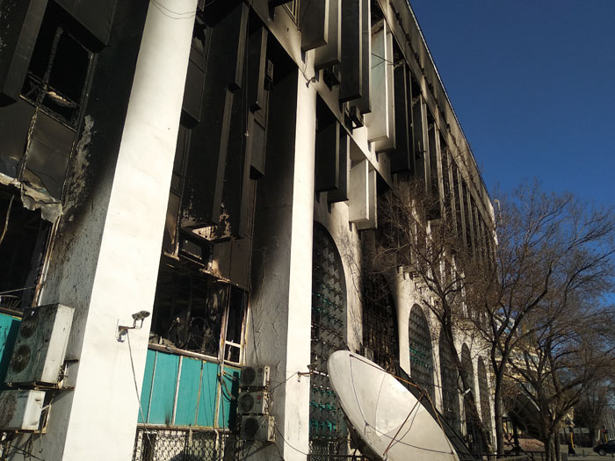

Figure 13: Charred communications building

Fire has destroyed much of this telecommunications building near Independence Square on the north side of Satpaev Ave. During the peak of violence and immediate aftermath, the city and its residents were cut off completely from communications with the outside world. This image and the events it symbolizes offer a reminder of our existential fragility, where our dependence on all things digital (communications, banking, purchases of food) and the ability to survive can be ended in an instant. The blue sky, matching that of the Kazakhstani state flag, may represent hope for a peaceful and prosperous future for the Kazakhstani state and its residents.
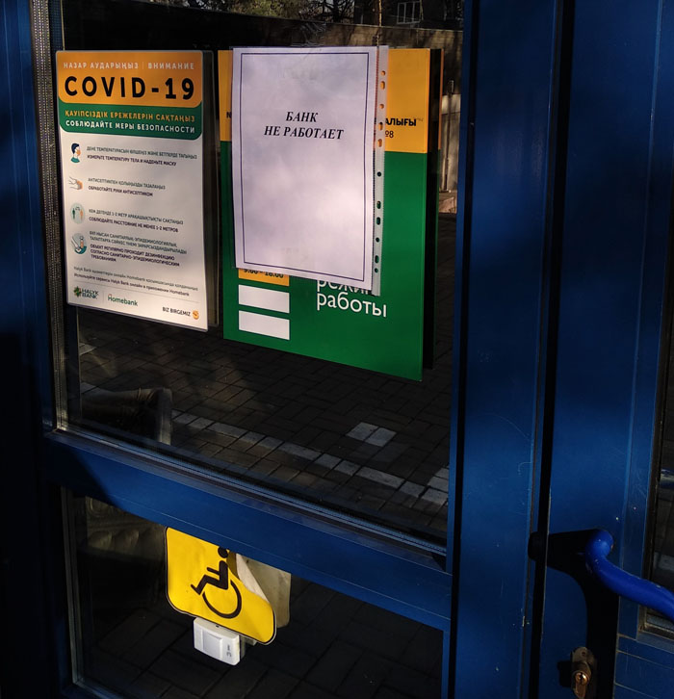

Figure 14: Bank closed

“Bank Closed” in Russian language on printer paper greets those hoping to gain access to money or any number of other financial transactions. To the left, another visual cue references an ongoing, two year crisis, that of the global pandemic. The accessibility system for those with disabilities is in its infancy. Pushing the button below the yellow sign may (or indeed may not) result in a security guard appearing to help. Shuttering the banking sector, including internet banking, must have had a devastating and as yet unknown impact on the city’s economy.

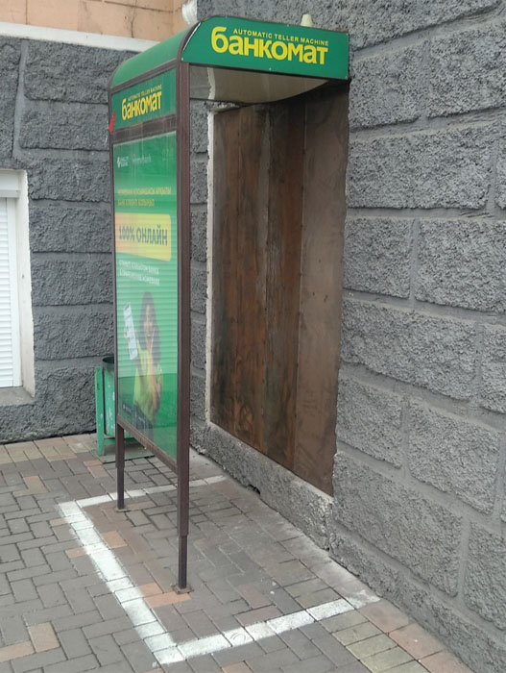

Figure 15: Bankomat (ATM) sealed off

On the corner of Kabanbay Batyr and Nursultan Nazarbayev streets, a bankomat (ATM) remains protected while simultaneously preventing public access. Just prior to this image being made, two elderly individuals approached the scene from different directions. Each was clearly distressed to see the machine not working, and a fairly animated discussion followed on the possible location of a properly functioning ATM. Once again, removing one’s access to one’s finances without any indication of when (or even if) access would be restored engenders a significant sense of anxiety and fear.

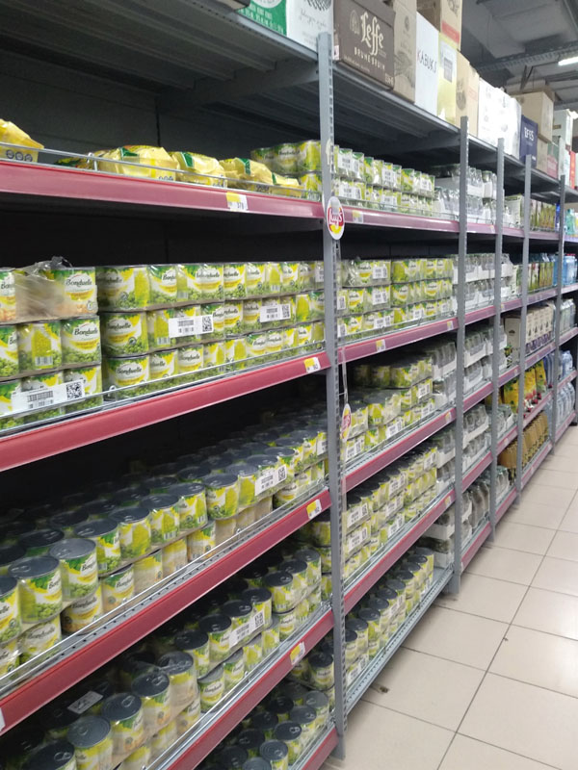

Figure 16: Beer replaced by canned peas

For the author, luckily, the nearest grocery store was not ransacked by looters. Under a state of emergency a blanket “no alcohol” policy outlawed such sales in all stores, markets, and restaurants. Here, an aisle normally stocked with beer is now stocked with canned peas. Another entire aisle dedicated to vodkas was stocked with pasta, yet another normally housing wine and spirits had canned beans. During the state of emergency, a city-wide curfew was also in effect between the hours of 11 pm and 7 am.

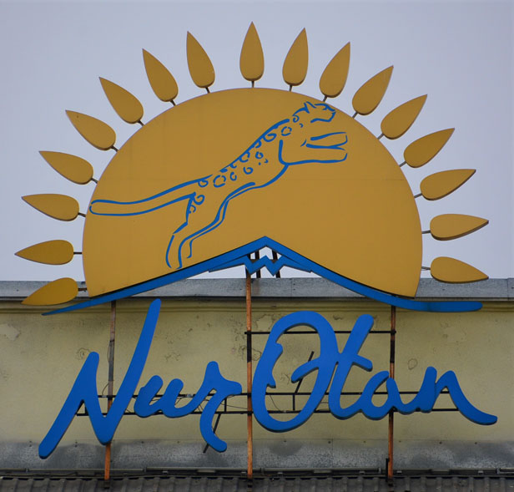

Figure 17: Nur-Otan political party

Nur-Otan (translates from Kazakh language to “Radiant Fatherland”), essentially the political party in Kazakhstan, boasts both Nazarbayev and Tokayev as members. The party’s logo, located at the top of one of its buildings in Almaty features the radiant sun motif from the Kazakhstani state flag, as well as a leaping snow leopard. While international television news coverage featured heavy destruction at the party’s headquarters, this building suffered no evident damage.
(Author’s note: On March 1, 2022 this political party, still headed by President Tokayev, changed its name to ‘Amanat,’ a move seen by many as the current president distancing himself and his presidency from former President Nazarbayev (Putz, 2022)).

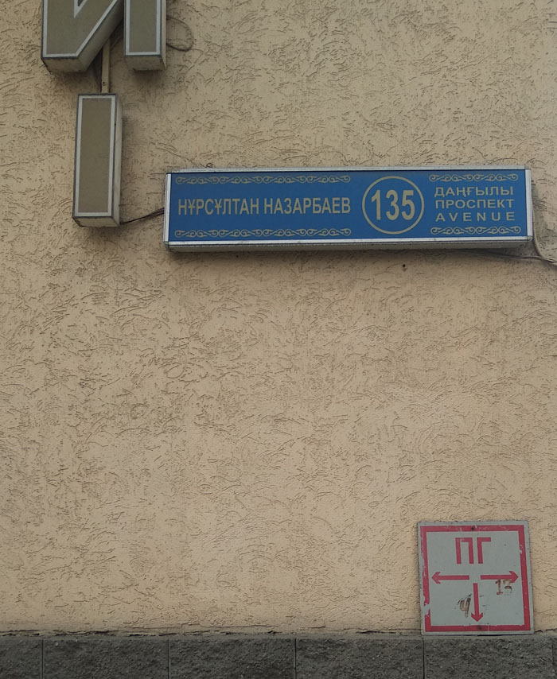

Figure 18: Intact Nursultan Nazarbayev Avenue sign

Moving north along Nursultan Nazarbayev Avenue revealed lessening damage to the street signs with distance from the Independence Square epicenter. While certain elements of the rioting mob seemed to be protesting the previous Nazarbayev regime and/or family and continued power and perceived corruption (witness figures 4 and 6 above), it is expected that the first President’s historical significance in Kazakhstan will remain. Narratives and myths may evolve over time, but the fact remains that Nazarbayev did lead Kazakhstan through a tumultuous transition from the Soviet past. This was done in tandem with economic growth, economic development, and political stability. As most states celebrate their “founding fathers’” it seems likely that Nazarbayev will remain a prominently important figure in the country’s history books..

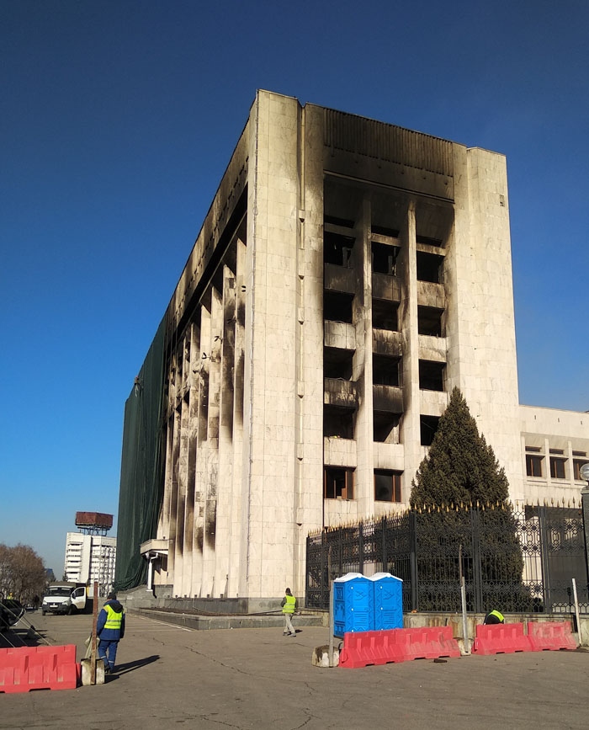

Figure 19: Looking north from behind the Akimat building

By January 14, the date of this image, cleanup of the Akimat building had begun. Here the façade of the building is being covered with army-green tarps, and charred damaged wood, glass, and other materials are being cleared. Just to the left of this scene are rows of army barrack-style tents that remind the viewer of the arduous task ahead of cleanup, removal, and repair. This remains a recurring theme throughout much of Almaty.

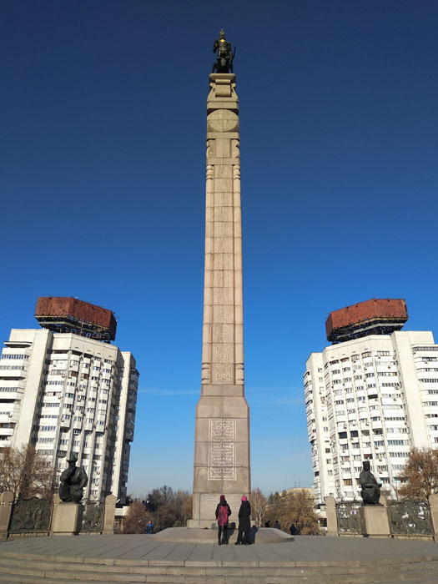

Figure 20: New Square and monument to Kazakhstan’s independence

Two people are seen at the base of Almaty’s monument to Kazakhstan independence. At the top, a Scythian warrior known as the “Golden Man” sits atop a winged snow leopard. At the bottom, a replica constitution is open, book-like, and includes the handprint of Nursultan Nazarbayev. While bullets struck the monument in at least two visible locations, it emerged from the chaos, smoke, and bloodshed intact and relatively unscathed.

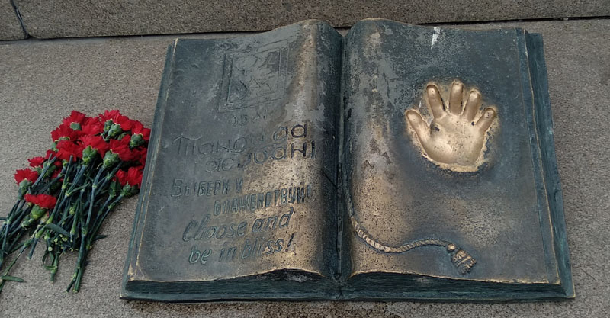

Figure 21: Flowers, replica of the Constitution, and hand of Nazarbayev

At the base of the Independence monument, this image offers a closer view of the book-like rendition of the Kazakhstan constitution. To the left, “Choose and be in Bliss” is etched in Kazakh, Russian, and English languages. On the right is the well-worn right hand imprint of the First President of Kazakhstan. Fresh flowers are often placed here.
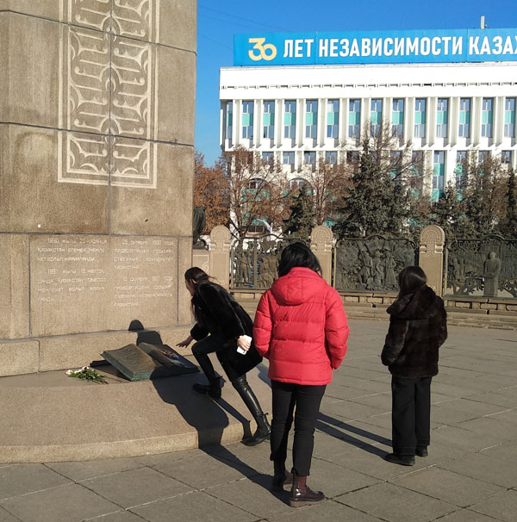

Figure 22: Return to normalcy?

Here can be seen young women performing a common ritual, placing one’s right hand in Nazarbayev’s for good luck. Above the scene, a Russian language sign trumpets Kazakhstan’s 30 years of independence.

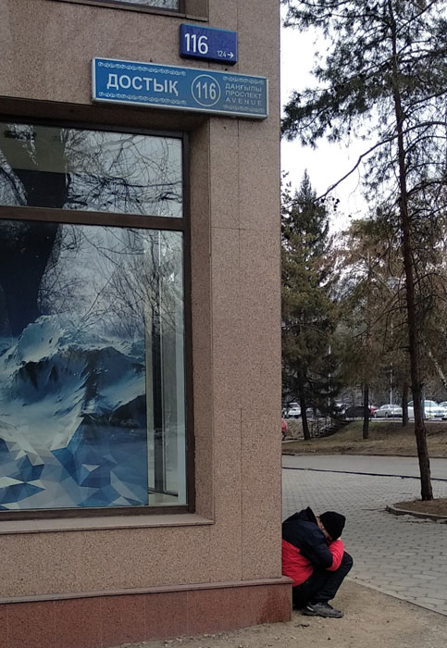

Figure 23: Friendship

Dostyk (In Kazakh language, translates to “Friendship”) Avenue with Avenue in Kazakh, Russian and English languages. While still in a state of emergency, most residents welcome the gradual return of urban functioning. Yet ‘normalcy’ varies greatly across Almaty residents. Though it appears the reinstated liquefied petroleum gas subsidies will remain in place for the short term, structural issues remain that will continue to erode people’s economic security. Poverty, largely inadequate pensions, income and wealth inequality, inflation, and devaluation of the local currency (tenge) conspire to produce palpable financial uncertainty.

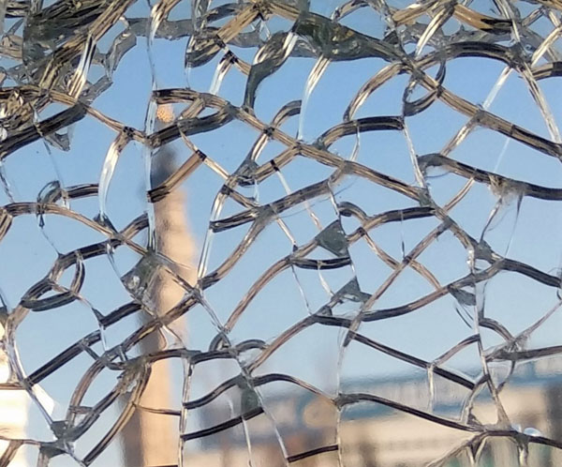

Figure 24: Reflection of independence monument in cracked glass

The Independence Monument, itself symbolizing the birth, strength, and continued existence of Kazakhstan, is reflected in fractured glass. With the violence of ‘tragic January’ fresh in the recent memories of residents here, relief at the restoration of order is tempered by uncertainty and unease. Are these surficial fissures in the political and social fabric, or are they deeper ruptures threatening the State’s cohesion? However events play out in the future, Almaty residents remain hopeful and resilient.

Conclusion

This photo essay offers primary source materials (images, personal observations and experience of the author, and interview responses of residents) to document the aftermath of this violent and landmark event in the history of independent Kazakhstan. The narrative here emanates from the perspective of local residents and forgotten ‘ordinary’ citizens so often overlooked in academic discussions focused on political elites and regional geopolitics.
Whatever power struggle dynamics continue to play out between the Nazarbayev and Tokayev factions, the people here hold out cautious hope that they be less public and less dramatic. If the official state narrative of terrorist action holds any validity, the prevailing hope is that the threat has been eliminated. In either case, Almaty has cautiously embraced a sense of peace, calm, and a seeming return to normalcy.

¹ First names of those willing to share their experiences have been changed. One interlocutor sent a link to Smayil (2022) referencing prison terms for spreading false information to explain her reluctance to speak on the matter.

References

Al Jazeera English. 2022. What just happened in Kazakhstan? Start Here.
https://www.youtube.com/watch?v=NEmvqSU7fk4&t=341s.

Cooley, A. 2022. Kazakhstan called for assistance. Why did Russia dispatch troops so quickly? Washington Post (January 9) https://www.washingtonpost.com/politics/2022/01/09/kazakhstan-called-assistance-why-did-russia-dispatch-troops-so-quickly/

Embassy of Kazakhstan. 2022. Kazakhstan’s Law Enforcement Agencies Continue to Provide Updates on Investigation into Tragic January Events.
https://www.gov.kz/memleket/entities/mfa-washington/press/news/details/316931?lang=en

Karibayeva, A. 2022. Kazakhstan’s Unrest Leaves Behind a Traumatized Society. Foreign Policy January 19.
https://foreignpolicy.com/2022/01/19/kazakhstan-unrest-trauma-aftermath/.

Putz, C. 2022. Nur Otan No More? Kazakhstan’s ruling party rebrands as ‘Amanat.’ The Diplomat (March 2) https://thediplomat.com/2022/03/nur-otan-no-more-kazakhstans-ruling-party-rebrands-as-amanat/

Smayil, M. 2022. Turgumbaev: The threat of up to 7 years in prison for spreading false information in an emergency (in Russian language). Tengrinews January 9:
https://tengrinews.kz/kazakhstan_news/turgumbaev-7-let-lisheniya-svobodyi-grozit-rasprostranenie-458564/.

